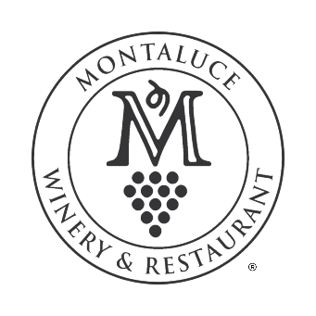

MEDIA RELEASE FORM

I, _______________________, grant permission to Montaluce Winery & Restaurant to use my image (photographs and/or video) for use in Media publications including Videos, Email Blasts, Brochures, Newsletters, Magazines, General Publications, Website and/or Social Media.

I hereby waive any right to inspect or approve the finished photographs or electronic matter that may be used in conjunction with them now or in the future, whether that use is known to me or unknown, and I waive any right to royalties or other compensation arising from or related to the use of the image.

I hereby agree to use any photographs and/or videos made on/with Montaluce Property in a legal and responsible manor, and I hereby release Montaluce Winery & Restaurant from any responsibility or culpability based on my use of said media.

Please initial the paragraph below which is applicable to your present situation:

_____ - I am 18 years of age or older and I am competent to contract in my own name. I have read this release before signing below, and I fully understand the contents, meaning and impact of this release. I understand that I am free to address any specific questions regarding this release by submitting those questions in writing prior to signing, and I agree that my failure to do so will be interpreted as a free and knowledgeable acceptance of the terms of this release.

_____ - I am the parent or legal guardian of the below named child. I have read this release before signing below, and I fully understand the contents, meaning and impact of this release. I understand that I am free to address any specific questions regarding this release by submitting those questions in writing prior to signing, and I agree that my failure to do so will be interpreted as a free and knowledgeable acceptance of the terms of this release.

Signature: ________________________________ Date: _______________________

Name (please print): ________________________________

Address: ______________________________________________________________________

Signature of parent or legal guardian: ________________________________
(if under 18 years of age)

